Lab Exercise 1– Install Terraform on Linux
Installing Terraform on Linux requires you to download the correct Terraform package, unpack, and execute it via the CLI. Follow the instructions below to ensure you do not miss any steps.

Download Terraform File for Windows
To find the latest version of Terraform for Windows:
1. Browse to the Download Terraform page.
2. Select the Linux tab under the Operating System heading. The latest version is preselected.
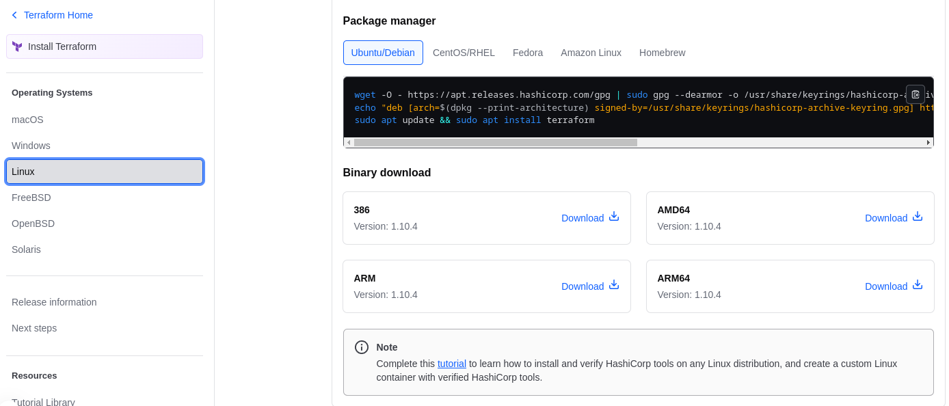

Add Terraform Path to System Environment Variables
To add the Terraform executable to the system's global path:
1. Simply Paste The Extracted Terraform Script in usr/local/bin path or usr/bin.

Verify Terraform Installation
To check the Terraform global path configuration:
1. Open a new command-prompt window.
2. Enter the command to check the Terraform version: terraform -version
terraform -version

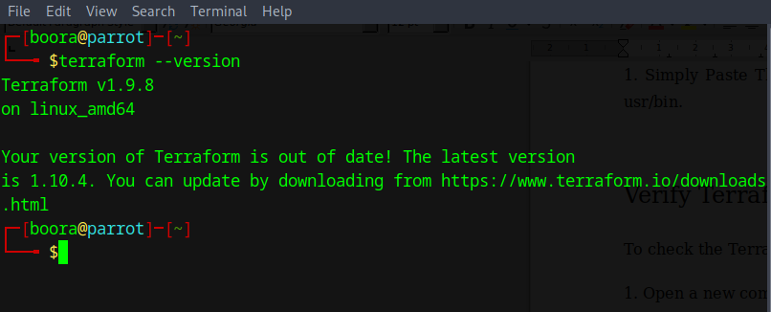
The output shows the Terraform version you downloaded and installed on your Windows machine.

